Waveshare ESP32-S3-Touch-LCD-3.49-V2 (PCBA v1.1 silkscreen)
This product is a high-performance, highly integrated microcontroller development board designed by Waveshare. It is equipped with a 3.49inch capacitive HD IPS screen, a highly integrated power management chip, a 6-axis IMU (3-axis accelerometer and 3-axis gyroscope), an RTC, a low-power audio codec chip, and echo cancellation circuitry, facilitating development and integration into end products.

Features
- Powered by the ESP32-S3R8 high-performance Xtensa 32-bit LX7 dual-core processor, with a main frequency of up to 240 MHz
- Supports 2.4 GHz Wi-Fi (802.11 b/g/n) and Bluetooth 5 (LE) with an onboard antenna
- Built-in 512 KB SRAM and 384 KB ROM, with stacked 8MB PSRAM and 16MB Flash
- Onboard 3.49inch capacitive touchscreen and IPS display, 172 × 320 resolution, 1.67M colors, capable of displaying color images clearly
- Equipped with a dual digital microphone array, enabling audio algorithms such as noise reduction and echo cancellation, suitable for precise voice recognition and near-field/far-field voice wake-up applications
- Integrated AXS15231B display driver chip, communicating via QSPI and I2C interfaces
- Onboard QMI8658 6-axis IMU (3-axis accelerometer, 3-axis gyroscope), capable of detecting device orientation changes, step counting, and other functions
- Onboard PCF85063 RTC chip for convenient RTC functionality implementation
- Onboard PWR and BOOT side buttons, configurable for custom function development
- Onboard 3.7V MX1.25 lithium battery charging interface
- Onboard TF card slot for flexible storage expansion and fast data transfer, suitable for data logging and media playback, simplifying circuit design
- Reserved 22PIN 2.54mm pitch communication solder pads, allowing users to connect external modules or expand functionality, enhancing development flexibility

Onboard Resources
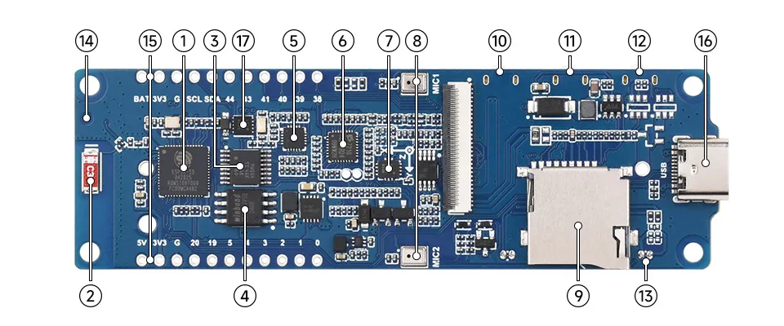

ESP32-S3-Touch-LCD-3.49 v2 Resource Overview
- ESP32-S3R8 Wi-Fi and Bluetooth SoC, up to 240MHz operating frequency, with onboard 8MB PSRAM
- Onboard Antenna Supports 2.4GHz Wi-Fi (802.11 b/g/n) and Bluetooth 5 (LE)
- TCA9554PWR 8-bit I2C GPIO expander chip
- W25Q128JVSI 16MB Flash memory
- ES8311 DAC Audio Codec High-performance, low-power audio digital-to-analog converter
- ES7210 ADC Audio Codec High-performance, low-power audio analog-to-digital converter, supports multi-microphone input
- QMI8658 3-axis accelerometer and 3-axis gyroscope, suitable for applications such as attitude sensing and motion recognition
- Dual Microphone Array Design Dual digital microphone arrays for advanced voice interaction functions
- TF Card Slot Supports FAT32-formatted TF card for data expansion
- RESET Button (Back Side) Press and hold the BOOT button, then click the RESET button to enter download mode
- PWR Button (Back Side) Enables power control via software configuration when using Lithium battery for power supply
- BOOT Button (Back Side) Press and hold the BOOT button, then click the RESET button to enter download mode
- MX1.25 2PIN Speaker Header (Back Side) Audio signal output, supports external speaker connection
- IPEX 1 Connector For connecting external antenna, enabled via resoldering an onboard resistor
- 22PIN 2.54mm Pitch Through-Hole Solder Pads For connecting external modules and enabling functional expansion
- Type-C Interface Used for program flashing and log printing
- PCF85063 RTC clock chip with time-keeping support

LCD Parameters
Parameter | Value | Parameter | Value
Display Panel | LCD | Display Size | 3.49inch
Resolution | 172 × 640 | Display Colors | 16.7M
Brightness | 350 cd/m² | Contrast Ratio | 1200:1
Display Interface | QSPI | Driver IC | AXS15231B
Touch Interface | I2C | Touch Type | Capacitiv

ESP32-S3-Touch-LCD-3.49-V2 (PCBA v1.1 silkscreen) Interface Overview
GPIO | LCD | SD Card | IMU | RTC | UART | I2S | KEY_IO | OUTPUT | Other | Wand | Note
IO0 |  |  |  |  |  |  | BOOT0 | IO0 |  | Readable Pushbutton | External Pushbutton in Parallel with BOOT?
IO1 |  |  |  |  |  |  |  | IO1 |  | RM3100 DRDY Tip (0x23)
IO2 |  |  |  |  |  |  |  | IO2 |  | RM3100 DRDY Ref (0x21)
IO3 |  |  |  |  |  |  |  | IO3 |  |  | NOT AVAILABLE - RESERVE
IO4 |  |  |  |  |  |  |  | IO4 | BAT_ADC | Battery Monitor
IO5 |  |  |  |  |  |  |  | IO5 |  | RM3100 DRDY Mid (0x22)
IO6 |  |  |  |  |  | I2S_DSOUT |  | IO6 |  |  | NOT AVAILABLE
IO7 |  |  |  |  |  | I2S_MCLK |  | IO7 |  |  | NOT AVAILABLE
IO8 |  |  |  |  |  |  |  |  | EXIO_INT |  | NOT AVAILABLE
IO9 | LCD_CS |  |  |  |  |  |  |  |  |  | NOT AVAILABLE
IO10 | LCD_SCL |  |  |  |  |  |  |  |  |  | NOT AVAILABLE
IO11 | LCD_D0 |  |  |  |  |  |  |  |  |  | NOT AVAILABLE
IO12 | LCD_D1 |  |  |  |  |  |  |  |  |  | NOT AVAILABLE
IO13 | LCD_D2 |  |  |  |  |  |  |  |  |  | NOT AVAILABLE
IO14 | LCD_D3 |  |  |  |  |  |  |  |  |  | NOT AVAILABLE
IO15 |  |  |  |  |  | I2S_SCLK |  | IO15 |  |  | NOT AVAILABLE
IO16 |  |  |  |  |  |  |  | IO16 | SYS_OUT |  | NOT AVAILABLE
IO17 | TP_SDA |  |  |  |  |  |  | IO17 |  |  | NOT AVAILABLE
IO18 | TP_SCL |  |  |  |  |  |  | IO18 |  |  | NOT AVAILABLE
IO19 |  |  |  |  |  |  |  | IO19 | U_N |  | NOT AVAILABLE - USB C
IO20 |  |  |  |  |  |  |  | IO20 | U_P |  | NOT AVAILABLE - USB C
IO21 | LCD_TE |  |  |  |  |  |  | IO21 |  |  | NOT AVAILABLE
IO38 |  | SD_CS |  |  |  |  |  | IO38 |  |  | NOT AVAILABLE
IO39 |  | SD_MOSI |  |  |  |  |  | IO39 |  |  | NOT AVAILABLE
IO40 |  | SD_MISO |  |  |  |  |  | IO40 |  |  | NOT AVAILABLE
IO41 |  | SD_SCLK |  |  |  |  |  | IO41 |  |  | NOT AVAILABLE
IO42 | LCD_BL |  |  |  |  |  |  | IO42 |  |  | NOT AVAILABLE
IO43 |  |  |  |  | TXD |  |  | IO43 |  | GPS | NOT AVAILABLE - Save for GPS
IO44 |  |  |  |  | RXD |  |  | IO44 |  | GPS | NOT AVAILABLE - Save for GPS
IO45 |  |  |  |  |  | I2S_DSDIN |  | IO45 |  |  | NOT AVAILABLE
IO46 |  |  |  |  |  | I2S_LRCK |  | IO46 |  |  | NOT AVAILABLE
IO47 |  |  | IMU_SDA | RTC_SDA |  | Audio_SDA |  | IO47 |  | Wand_SDA | SHARED SDA (expander is 0x20)
IO48 |  |  | IMU_SCL | RTC_SCL |  | Audio_SCL |  | IO48 |  | Wand_SCL | SHARED SCL (expander is 0x20)
RESET |  |  |  |  |  |  | RESET |  |  |  | NOT AVAILABLE
EXIO0 | TP_INT |  |  |  |  |  |  | EXIO0 |  |  | NOT AVAILABLE
EXIO1 | BL_EN |  |  |  |  |  |  | EXIO1 |  |  | NOT AVAILABLE
EXIO2 |  |  | IMU_INT1 |  |  |  |  | EXIO2 |  |  | NOT AVAILABLE
EXIO3 |  |  | IMU_INT2 |  |  |  |  | EXIO3 |  |  | NOT AVAILABLE
EXIO4 |  |  |  | RTC_INT |  |  |  | EXIO4 |  |  | NOT AVAILABLE
EXIO5 | LCD_RST |  |  |  |  |  |  | EXIO5 |  |  | NOT AVAILABLE
EXIO6 |  |  |  |  |  |  |  | EXIO6 | SYS_EN |  | NOT AVAILABLE
EXIO7 |  |  |  |  |  | NS_MODE |  | EXIO7 |  |  | NOT AVAILABLE

ESP32-S3-Touch-LCD-3.49-V2 (PCBA v1.1 silkscreen) Interface Overview
